# SQL Server Cluster details

# <https://www.ourtechideas.com/blog/sql-cluster-details/>

# 

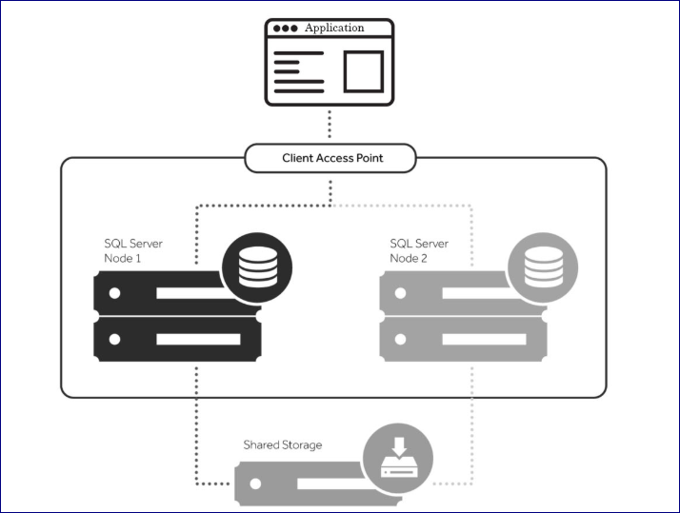

# Scenario

A **cluster** includes two or more physical servers, called nodes; identical configuration is recommended. One is identified as the active node, on which a **SQL** Server instance is running the production workload, and the other is a passive node, on which **SQL** Server is installed but not running. In this post, we have tried to share a few ways to gather information about any running SQL cluster setup.

## How will you find whether the SQL Server is configured in a failover cluster?

SELECT SERVERPROPERTY('IsClustered')

**Result (**This returns a 0=NO or 1=YES)

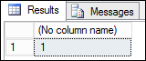

## How will you find the node that the SQL Server is currently running on?

SELECT SERVERPROPERTY('ComputerNamePhysicalNetBIOS')

**Result**

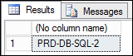

## Find cluster nodes by querying a DMV

We can also find cluster nodes by querying a data management view (DMV), but this DMV doesn’t show which nodes are active.

**Using DMV**

SELECT * FROM sys.dm_os_cluster_nodes

**Result**

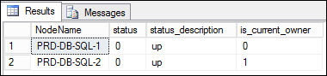

## Find information from SERVERPROPERTY

We can also find Machine Name, Server Name & Instance Name by below SERVERPROPERTY

**Using TSQL statement**

SELECT SERVERPROPERTY ('MachineName') as [Machine Name]

SELECT SERVERPROPERTY('InstanceName') as [Instance Name]

SELECT SERVERPROPERTY('ServerName') as [Server Name]

**Result**

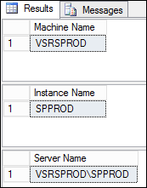

## Find the SQL cluster details & status all together!

**Using TSQL query**

-- =====================================================

-- Owner: Soyeluddin Biswas == Date: 08/11/2019

-- Email: soyel@ourtechideas.com & st.biswas99@gmail.com

-- =====================================================

use master

go

select

@@SERVERNAME as [SQL Instance]

,NodeName as [Cluster Node]

,CASE

WHEN status=0 THEN 'RUNNING'

WHEN status=1 THEN 'Down'

WHEN status=2 THEN 'Paused'

WHEN status=3 THEN 'Joining'

WHEN status=-1 THEN 'Unknown'

END as [Node Status]

,CASE

WHEN is_current_owner=0 THEN 'No'

WHEN is_current_owner=1 THEN 'Yes'

END as [Current Owner]

from sys.dm_os_cluster_nodes

**Result**

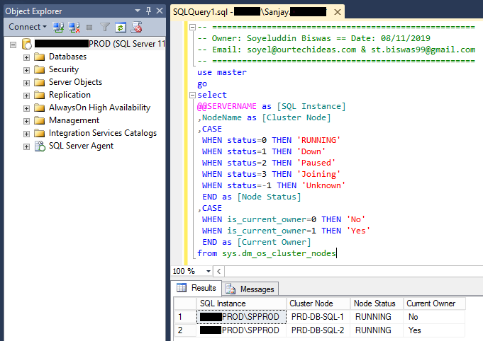

**Using Failover Cluster Manager GUI**

Open Failover Cluster Manager and click on Roles. Then go to the bottom of the window and click on Resources. You will get the same cluster information as described in the below screenshot.

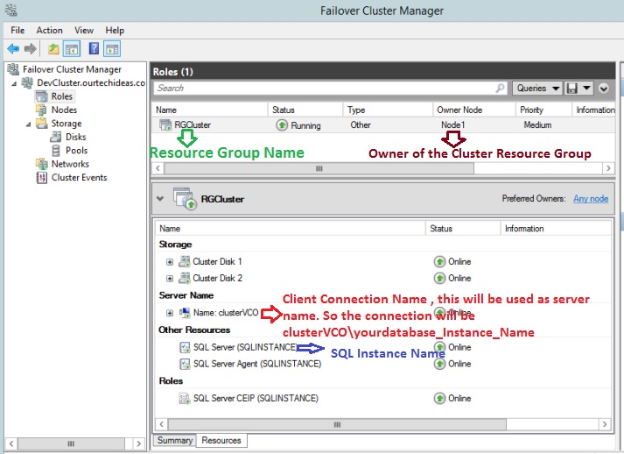

**Failover Cluster Manager**

**when you click on nodes, you will see all the nodes participated in the cluster.**

